**Schizophrenia Monitoring System**

**Introduction**

This system is for monitoring schizophrenic patients’ rooms in psychiatric hospitals. It gathers data of movement of patient, VOCs percentage, and Temperature. Data is gathered by sensors and visualized on the dashboard.

**Sensor Integration**

System gathers data from the patient and room environment using sensors. Movement acceleration of the patient is measured using MPU6050. VOCs and temperature inside the room are in direct relationship. Integration between CCS811 for measuring VOCs, and DS18B20 for measuring Temperature helps in detecting relation between them that helps in quick assessment and ventilation of room when needed.

**Signal Interpretation Techniques**

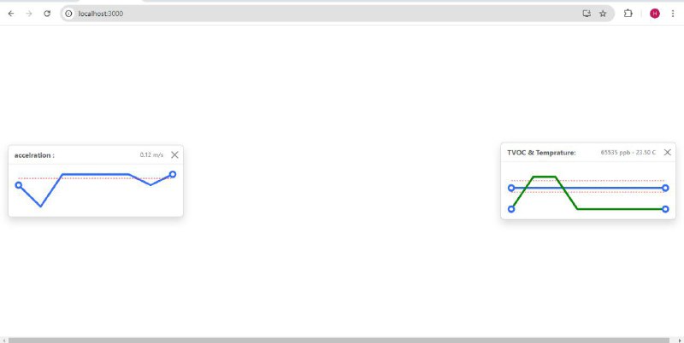System is used to gather data from the patient while not in continuous observation and care from nurses by detecting his movement acceleration in the wearable watch in his hand gathering data of acceleration in both directions and altering an alarm at schizophrenic episode. The other part of the system gathers data from room environment which are unable to be changed into quantized data visually. CCS811 and DS18B20 change things that can’t be seen as VOCs and temperature into signals which are transmitted to the server then to the dashboard and visualized as graphs and readings as shown in the figure.

**Performance of the system in a test environment**

*The wearable watch containing MPU6050, ESP32, and battery measures acceleration of the patient’s hand to detect schizophrenic episodes and transmit data to the dashboard using Bluetooth, then alters an alarm on the dashboard with a sound of warning and a message appears on the dashboard.

*The other part of the system consisting of Arduino Nano, CCS811, and DS18B20 powered with a battery and connected to the dashboard for data transmission also triggers an alarm at threshold when VOCS level increase in the room as a result of using detergents and when temperature increases. The alarm is also a sound from the dashboard and a message with the danger warning.

**How to deal with the system**

*Put the wearable watch in the patient’s hand, and other sensors in the room then connect it to the device on which the dashboard will be on it.

* ESP should be connected to the dashboard with Bluetooth. Then using command prompt the dashboard can be opened showing graphs and readings.